TASK-1
Feature | Ethernet Cable (Copper) | Fiber Optic Cable (Glass/Plastic)
Transmission Method | Transmits data using electrical signals over copper wires. | Transmits data using pulses of light through extremely thin strands of glass or plastic.
Distance & Interference | Signal degrades over longer distances (usually limited to about 100 meters) and can be affected by electromagnetic interference (EMI). | Can carry signals for miles without losing strength and is completely immune to electromagnetic interference.
Speed & Bandwidth | Excellent for local networks (usually up to 1Gbps to 10Gbps on standard cables). | Offers vastly superior bandwidth and speed capabilities (frequently handling 100Gbps+ for massive data loads).

TASK-2
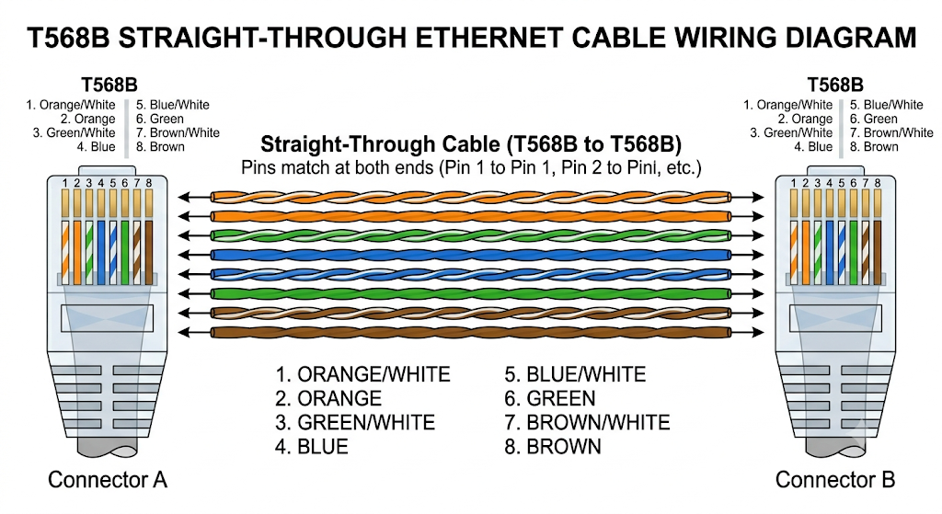

TASK-3
Quick 6-Step Summary
- Strip: Remove ~1 inch of the cable's outer jacket.
- Trim & Straighten: Cut off the central plastic divider and untwist the wires.
- Order Wires (T568B): Line them up from left to right:
  - White/Orange, Orange, White/Green, Blue, White/Blue, Green, White/Brown, Brown.
- Cut: Trim wires evenly to ~0.5 inches long.
- Insert: Slide wires into the RJ45 plug (clip facing down).
- Crimp: Insert into the crimp tool and squeeze hard.

TASK-4
For a 10-PC LAN gaming setup in a compact café space, standard Ethernet cables (like Cat6) paired with an RJ45 crimper are the ideal choice. Fiber optics and specialized tools like fiber cleavers offer insane speeds over long distances, but they are expensive, fragile, and unnecessary for short indoor runs. Ethernet easily handles 1–10 Gbps speeds with ultra-low latency, making it plenty fast for intense multiplayer gaming while staying budget-friendly and easy to assemble or repair.

